|  |  |
| --- | --- |
|  |  |

**MINI PROJECT TITLE**

CLAP SWITCH

Mini Project Report

Sumbitted By :

KUSH JAYESH GADA

Roll no : 14

MEET NILESH BHANUSHALI  
Roll no : 05

MEET ABHAY BHANSALI

Roll no : 04

Subject name :

DIGITAL SYSTEM DESIGN

Department of Electronics and telecommunication Engineering

K.J.Somaiya Institute of Engineering and Information Technology, Sion, Mumbai-22

**INTRODUCTION**

Clap switch is an interesting hobby circuit which turns on the lights with a clap sound. Although its name is “**Clap switch**”, but it can be turned ON by any sound of approximately same pitch of Clap sound. The main component of this clap switch circuit is the **Electric Condenser Mic**, which has been used as a sound sensor. Condenser Mic basically converts sound energy into electrical energy, that in turns used to trigger 555 timer IC, through a Transistor. And triggering of 555 IC would turn ON the LED, which will be automatically turned OFF after some time. I have made this circuit as simple as possible, you can find many complex Clap switches (using 555 IC) with some more components in it, and merely doing the same thing. Even make things simpler require more effort than making it complex.

**BUGLAR Alarm Circuit Diagram**

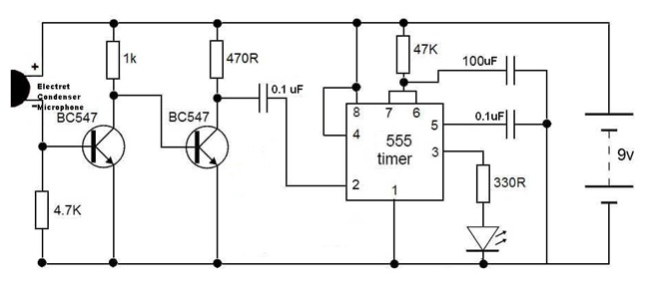

**Components Required**

* 555 IC
* Transistor – BC547
* Resistor – 470KΩ
* Resistor – 470Ω
* Resistor – 4.7Ω
* Resistor – 330KΩ
* Capacitor – 10µF
* Capacitor – 0.1µF
* 9V Battery
* LED
* Mini Buzzer
* Breadboard
* Connecting Wires

### Design

This circuit is made with a low cost hardware using IC 555 timer, buzzer, a few resistors and capacitors. It is made to be working reliably as it has simple to use and not so sensitive hardware like 555 timer, ceramic buzzer, capacitors, etc.

Although no exclusive arrangement is used to make any compensation for the variable parameters, the circuit by default is made to be robust and easy to use. It is very user friendly as when we clap the LED and the BUZZER goes on.

### Working

You can see the circuits and connections in the above schematic diagram of clap switch. Initially the transistor is in OFF state because there is not enough (0.7v) base-emitter voltage to turn it ON.  And the point A is at high potential, and point A is connected to Trigger pin 2 of 555 IC, as a result Trigger pin 2 is also at high potential. As we know that, to trigger the 555 IC through Trigger PIN 2, the voltage of the PIN 2 must be below Vcc/3. So at this stage LED is OFF.

Now when we produce some sound near condenser mic, this sound will be converted into electrical energy and it will raise the potential at the Base, which will turn the Transistor ON. As soon as the transistor becomes ON, the potential at Point A would become low and it will trigger the 555 IC because of the low voltage (below Vcc/3) at Trigger Pin 2 and LED will turn ON. We have connected the LED to Output PIN 3 of 555 IC through a 220ohm resistor.

After some time LED will be turned OFF automatically because we are using **555 timer IC in Monostable Mode.**

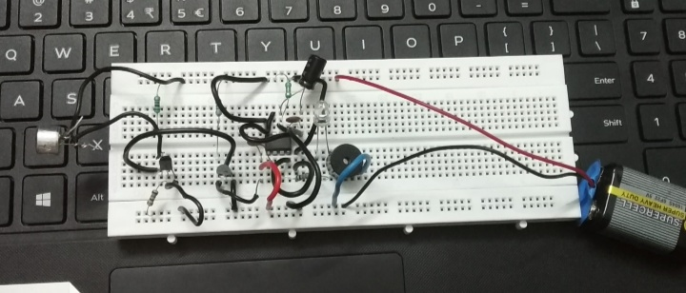

### Conclusion

In conclusion, using Electric Condenser Mic for sensing the sound, transistor to trigger the 555 timer IC and 555 IC to turn ON the LED through a low voltage trigger.